**WEB API (Inventory Service):**

**Product Table:**

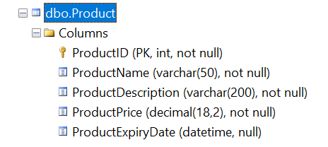

1. **Get list of all products.**

<https://localhost:44326/api/product/>

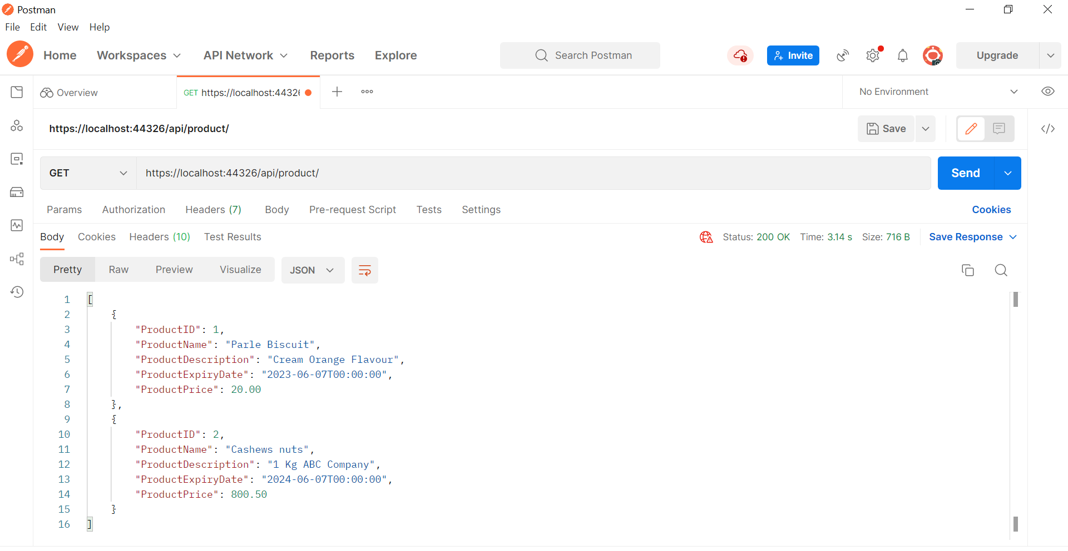

1. **Get specific product by product id**

<https://localhost:44326/api/product/2>

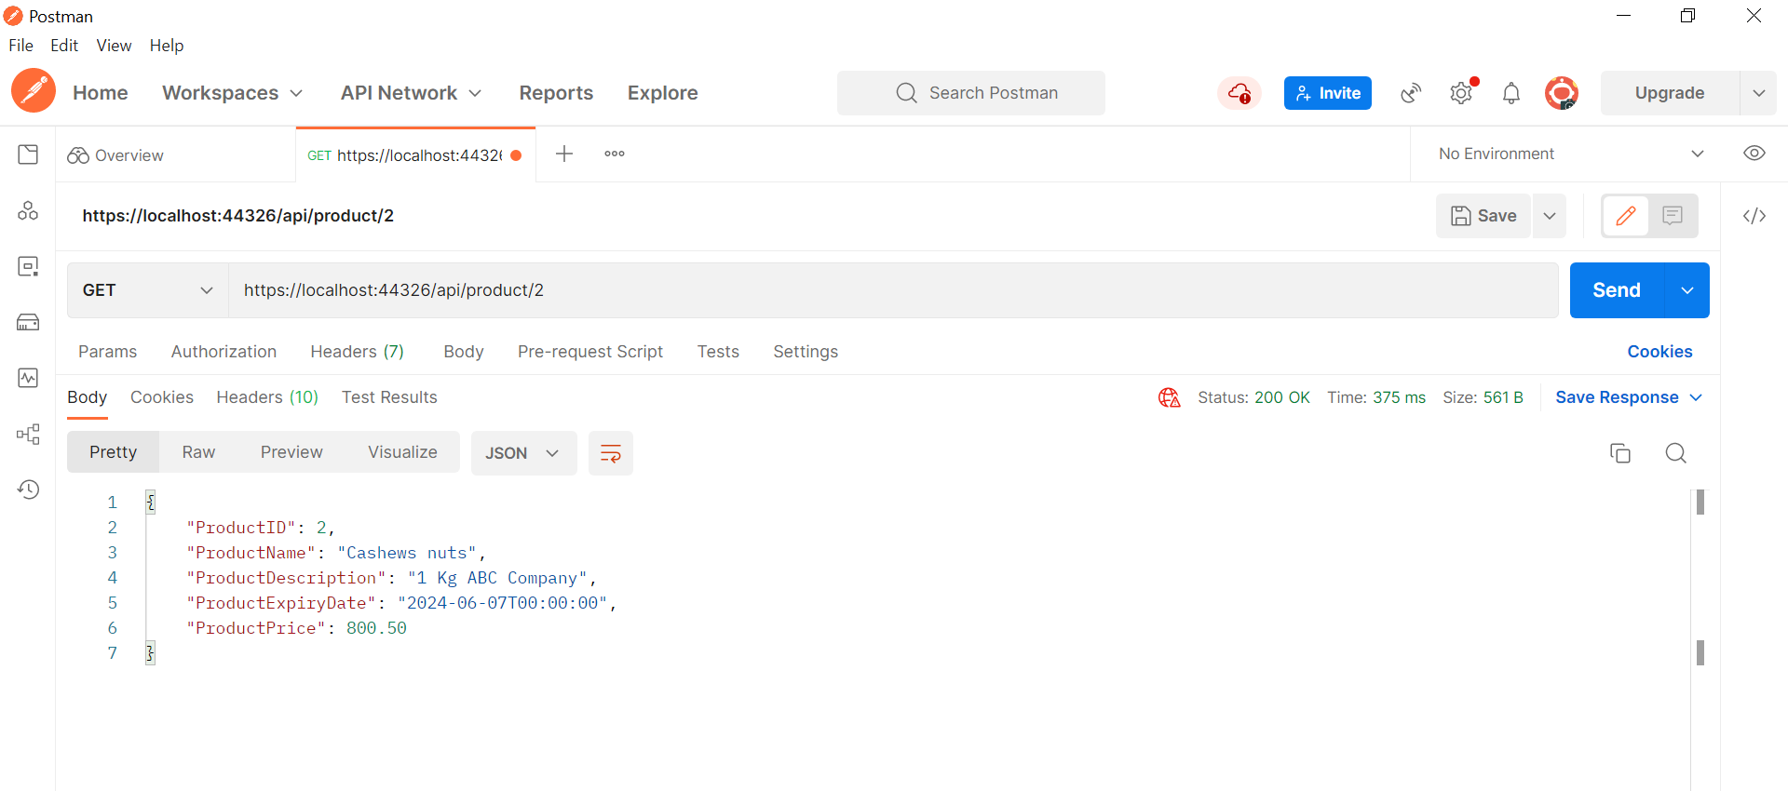

* 1. **Return message if Product is not found.**

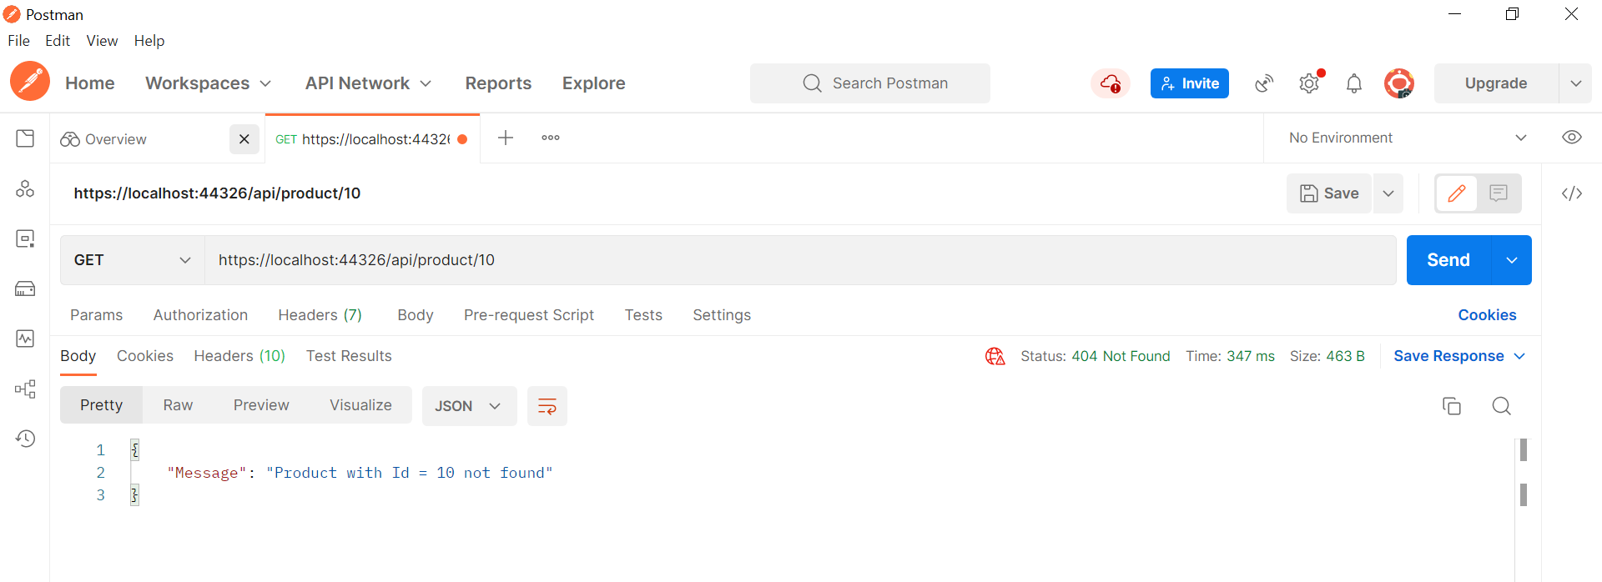

1. **Add product**

<https://localhost:44326/api/product/>

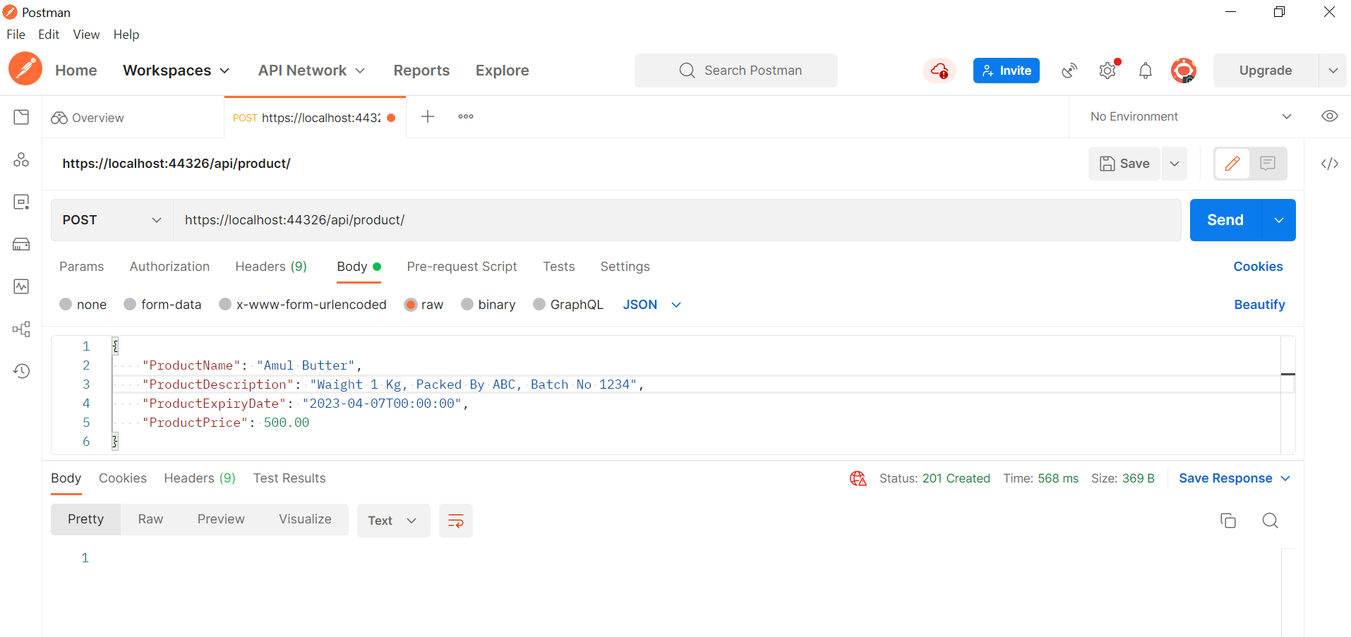

* 1. **Validation if user insert incorrect data or missed required data.**

<https://localhost:44326/api/product/>

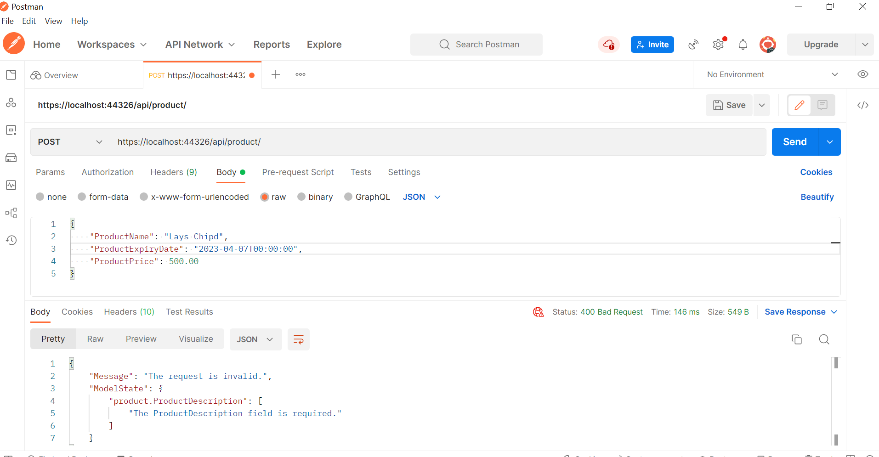

1. **Edit existing product**

<https://localhost:44326/api/product/>2

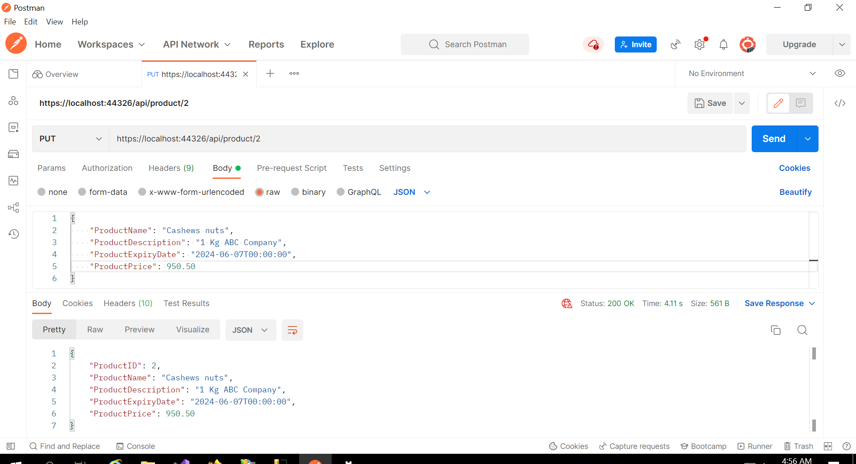

**Updated Product Price:**

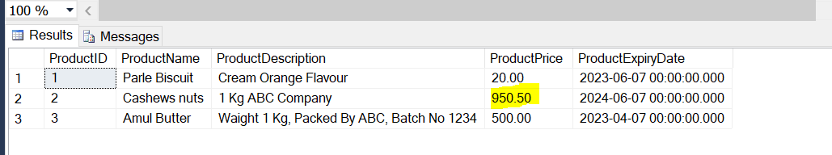

* 1. **Validation if user edits incorrect data.**

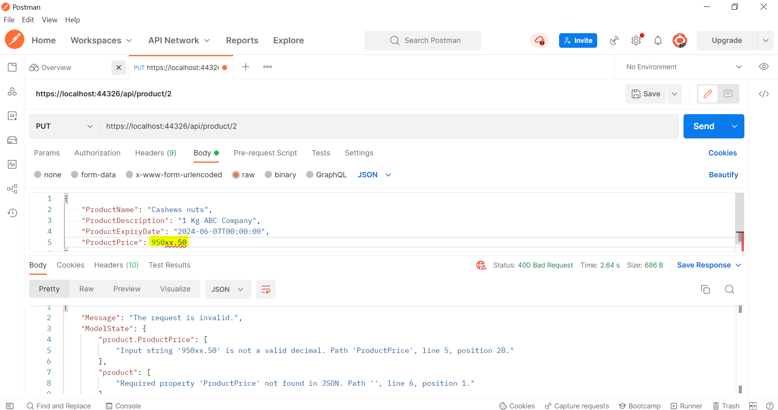

1. **Delete product**

<https://localhost:44326/api/product/3>

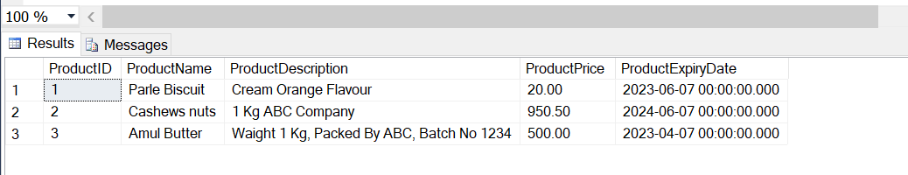

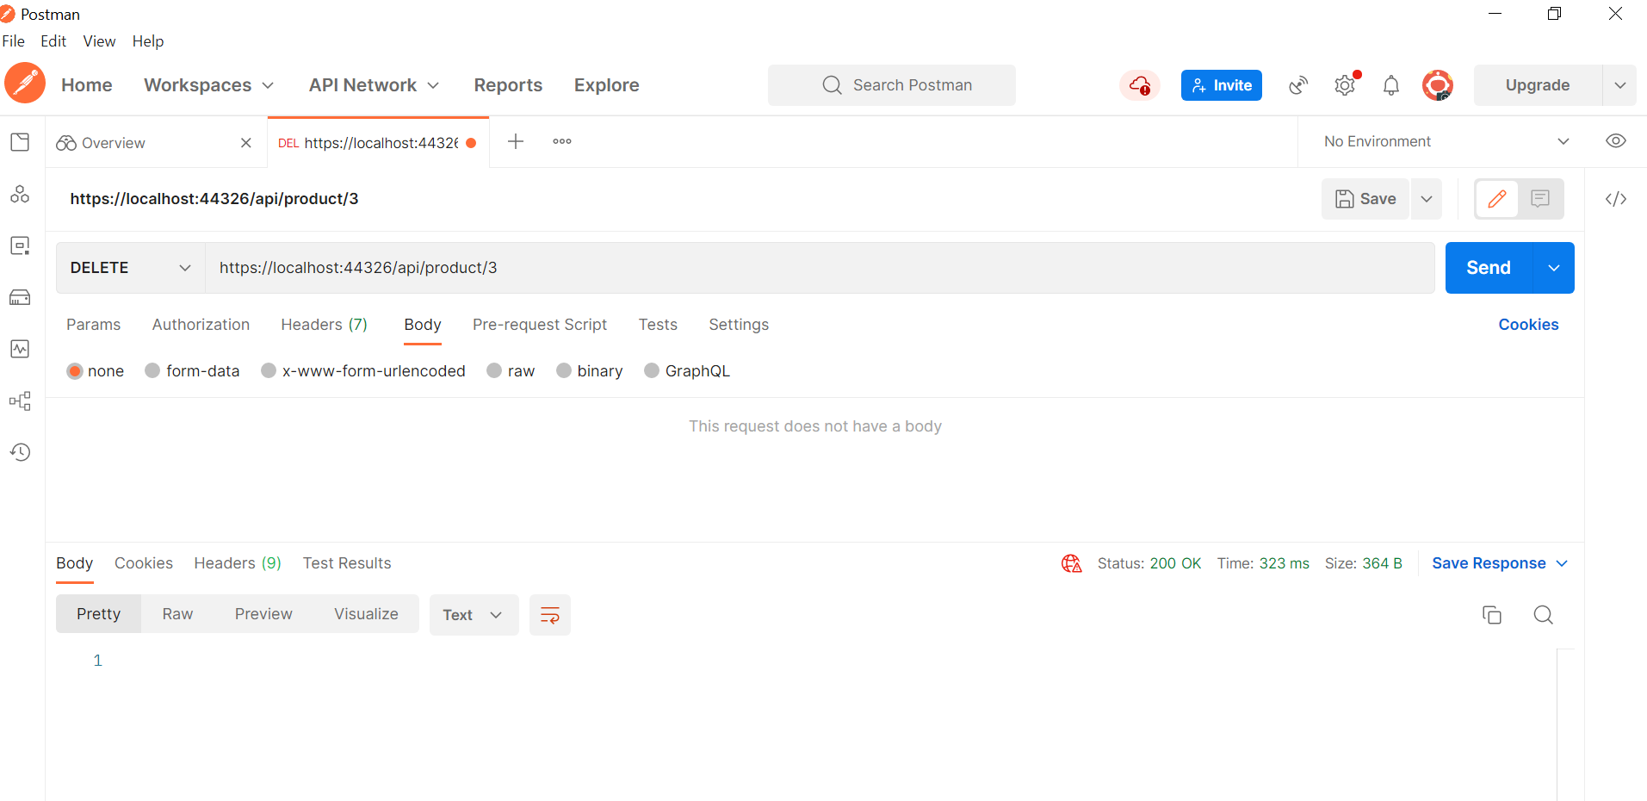

Product with Id 3 deleted.

